Practical No. 1
Aim: Load a Dataset, Identify Missing Values, Handle Them, and Remove Outliers.
Name: Prerna Deepak Gyanchandani | Roll No.: KFPMSCCS06
Date: 21/2/26 | Sign:

Method 1 : Using Median, Mode to impute missing values
Code:
import seaborn as sns
import pandas as pd
# Load the titanic dataset into a pandas DataFrame (built-in dataset)
df = sns.load_dataset('titanic')
# Display the first few rows
print(df.head())
# Identify missing values
print("Missing Values: \n", df.isnull().sum())
# Handle missing values - imputing (filling missing values)
# Fill numerical columns with the mdeian
# Fill categorical columns with the mode
for col in df.select_dtypes(include=['number']):
df.fillna({'col':df[col].median()}, inplace=True)
for col in df.select_dtypes(include=['object']):
df.fillna({'col':df[col].mode()[0]}, inplace=True)
# Detect and remove outliers using IQR method
Q1 = df.select_dtypes(include=['number']).quantile(0.25)
Q3 = df.select_dtypes(include=['number']).quantile(0.75)
IQR = Q3 - Q1
df_cleaned = df[~((df.select_dtypes(include=['number']) < (Q1 - 1.5 * IQR)) | (df.select_dtypes(include=['number']) > (Q3 + 1.5 * IQR))).any(axis=1)]
print("\nShape before outlier removal: ", df.shape)
print("\nShape after outlier removal: ",df_cleaned.shape)
print(df.isnull().sum())
print(df.info())
Output:
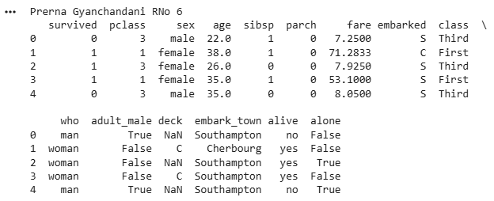
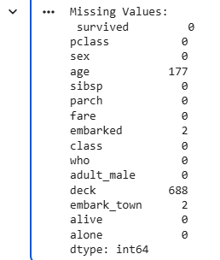
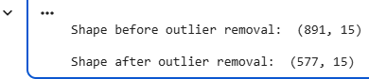
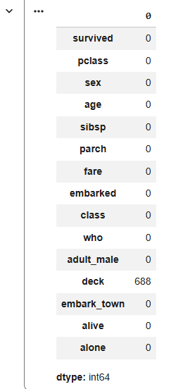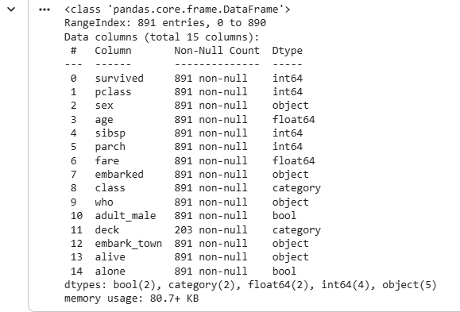
Method 2: Using knn imputer to fill missing values
Code:
# knn imputer , gets neighbors and then calculates mean
import pandas as pd
import numpy as np
import seaborn as sns
from sklearn.impute import KNNImputer
from scipy.stats import zscore
import matplotlib.pyplot as plt
# Load dataset
df = sns.load_dataset("titanic")
print("Original Shape: ", df.shape)
# Percentage of missing values
missing_percent = df.isnull().mean() * 100
print("\nMissing Percentage:\n",missing_percent)
# KNN Imputation
num_cols = df.select_dtypes(include=['number']).columns
imputer = KNNImputer(n_neighbors=5) # nearest neighbor in knn
df[num_cols] = imputer.fit_transform(df[num_cols])
# Z - Score Outlier Removal
z_scores = np.abs(zscore(df[num_cols]))
df_clean = df[(z_scores < 3 ).all(axis=1)]
print("\nShape after cleaning: ",df_clean.shape)
# Boxplot Visualization
for col in num_cols:
sns.boxplot(x=df_clean[col])
plt.title(f"Boxplot of {col}")
plt.show()
Output:
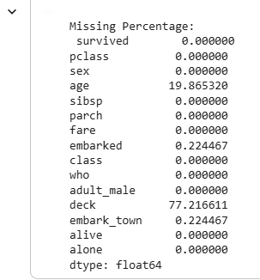
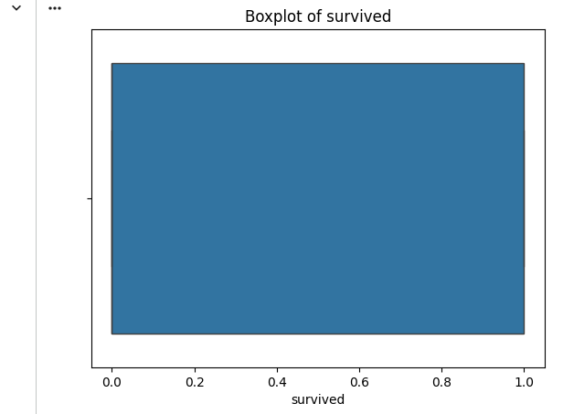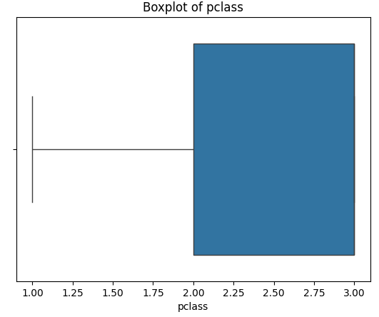
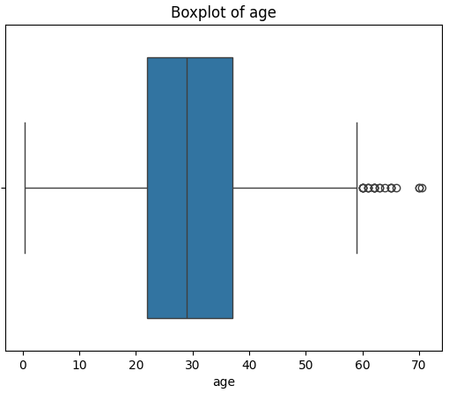
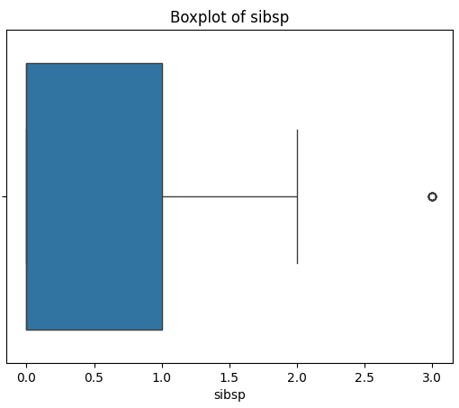
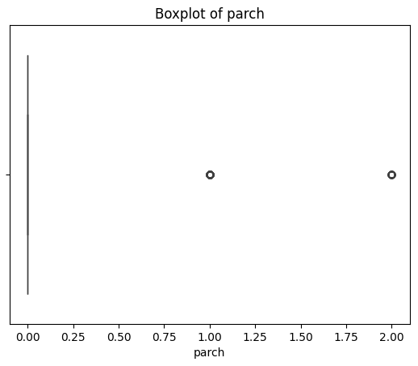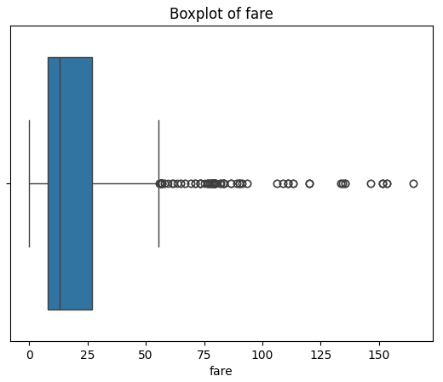

Practical No. 2
Aim: Perform feature scaling (standardization, normalization) and transformation on a numerical dataset.
Name: Prerna Deepak Gyanchandani | Roll No.: KFPMSCCS06
Date: 24/2/26 | Sign:

Method 1 : Code:
from sklearn.datasets import load_diabetes #Loading dataset
from sklearn.preprocessing import StandardScaler, MinMaxScaler, PowerTransformer #preprocessing
import pandas as pd
import numpy as np
# Load inbuilt dataset (Diabetes dataset)
data = load_diabetes()
#print(data) - text format (array, dictionary)
df = pd.DataFrame(data.data, columns=data.feature_names)
# Standardization (Z-score)
scaler_standard = StandardScaler()
df_standardized = pd.DataFrame(scaler_standard.fit_transform(df), columns=df.columns)
# Normalization (Min - Max Scaling)
scaler_minmax = MinMaxScaler()
df_normalized = pd.DataFrame(scaler_minmax.fit_transform(df), columns=df.columns)
# Log Transformation (for skewed data)
df_transformed = df.copy()
df_transformed = df_transformed.apply(lambda x: np.log1p(x)) # lambda is used for mapping and modifying
print("Prerna Gyanchandani RNo 6")
print("\nOriginal Data (first 5 rows):\n",df.head())
print("\nStandardized Data: \n",df_standardized.head())
print("\nNormalized Data: \n",df_normalized.head())
print("\nLog Transformed Data:\n",df_transformed.head())
Output:
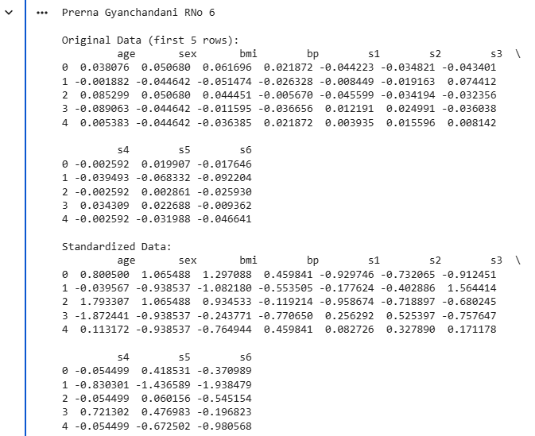
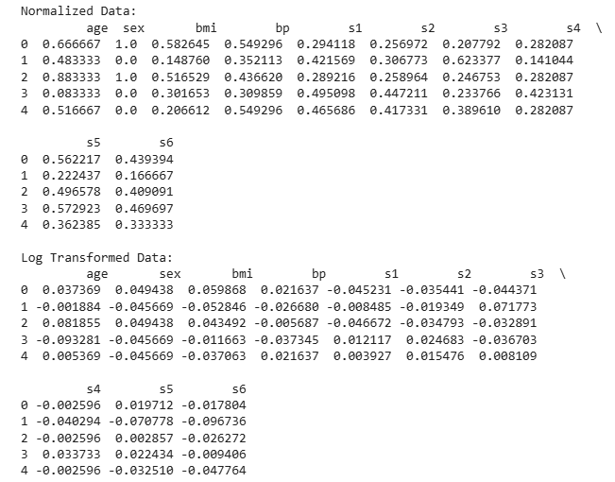
Method 2 - Using Robust Scaler
from sklearn.datasets import load_diabetes #Loading dataset
from sklearn.preprocessing import StandardScaler, MinMaxScaler, RobustScaler #preprocessing
import pandas as pd
import numpy as np
# Load inbuilt dataset (Diabetes dataset)
data = load_diabetes()
#print(data) - text format (array, dictionary)
df = pd.DataFrame(data.data, columns=data.feature_names)
# Standardization (Z-score)
scaler_standard = StandardScaler()
df_standardized = pd.DataFrame(scaler_standard.fit_transform(df), columns=df.columns)
# Normalization (Min - Max Scaling)
scaler_minmax = MinMaxScaler()
df_normalized = pd.DataFrame(scaler_minmax.fit_transform(df), columns=df.columns)
# Robust Scaler
rs = RobustScaler()
df_robust = pd.DataFrame(rs.fit_transform(df), columns=df.columns)
# Auto log transform for skewed columns
df_transformed = df.copy()
for col in df_transformed.columns:
if abs(df_transformed[col].skew()) > 1:
df_transformed[col] = np.log1p(df[col])
print("Prerna Gyanchandani RNo 6")
print("\nOriginal Data (first 5 rows):\n",df.head())
print("\nStandardized Data (Standard Scaler): \n",df_standardized.head())
print("\nNormalized Data (Min Max Scaler): \n",df_normalized.head())
print("\nRobust Scaler: \n",df_robust.head())
print("\nLog Transformed Data:\n",df_transformed.head())

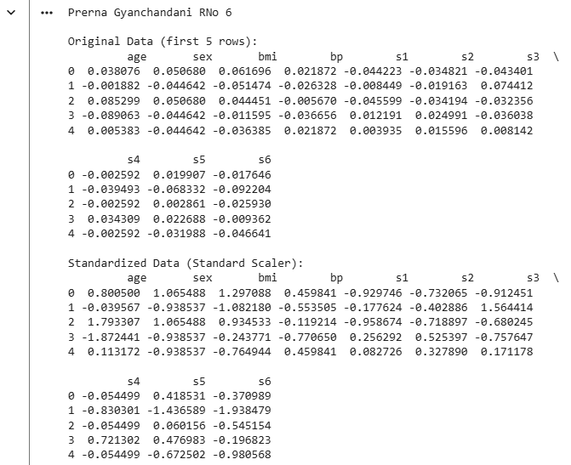
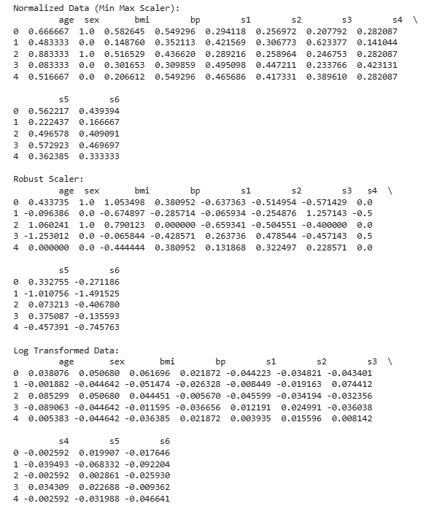

Practical No. 3
Aim: Handle structured (CSV), semi-structured (JSON), and unstructured data (text files) to understand differences.
Name: Prerna Deepak Gyanchandani | Roll No.: KFPMSCCS06
Date: 25/2/26 | Sign:

Method 1 (NLTK): Code:
import json
import pandas as pd
import seaborn as sns
import nltk
from nltk.corpus import gutenberg
# Handling Structured Data (CSV) - Using Seaborn's Titanic dataset
df_csv = sns.load_dataset('titanic') # Load inbuilt Titanic dataset
print("\nStructured Data (CSV):\n",df_csv.head())
# Handling Semi-Structured Data (JSON) - Using Sample JSON Dictionary
data_json = {
"name": "Prerna Gyanchandani",
"age": 20,
"city": "Mumbai",
"skills": ["Python", "Machine Learning", "AI", "Robotics"]
}
df_json = pd.json_normalize(data_json) # Convert JSON to DataFrame
print("\nSemi-Structured Data (JSON):\n",df_json)
# Handling Unstructured Data (text) - Using NLTK Gutenberg Corpus
nltk.download('gutenberg')
text_data = gutenberg.raw('shakespeare-hamlet.txt')
print("\nUnstructured Data (Text):\n",text_data[:200])
# print("\nTo retreive fields in dataset: ",gutenberg.fileids())
Output:
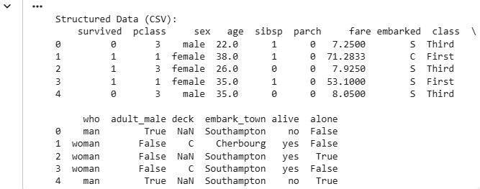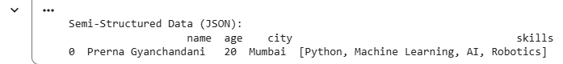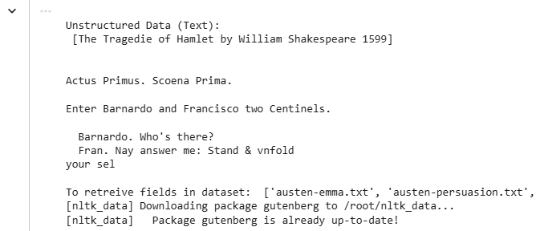

Method 2 (TF-IDF) : Code:
import pandas
import json
from collections import Counter
from sklearn.feature_extraction.text import TfidfTransformer, TfidfVectorizer
df = pd.DataFrame([{"Name":["Prerna","Gyani"], "Age":[20,25]}])
df.to_csv("data.csv",index=False)
df.to_json("data.json")
text = "data science is science of data"
words = text.split()
# Flatten JSON
data = json.load(open("data.json")) # same as with open('data.json', 'r') as f: data = json.load(f)
print (data)
df_json = pd.json_normalize(data) # Convert JSON to DataFrame
print(df_json)
freq = Counter(words)
# Word Frequency
print("Word Frequency", freq)
# TF - IDF
vectorizer = TfidfVectorizer()
X = vectorizer.fit_transform([text])
print("TF-IDF Shape:",X.shape)
Output:
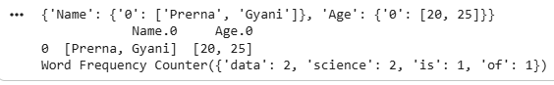

Practical No. 4
Aim: Compute measures of central tendency (mean, median, mode) and dispersion (variance, standard deviation).
Name: Prerna Deepak Gyanchandani | Roll No.: KFPMSCCS06
Date: 27/2/26 | Sign:

Method 1 : Code:
import pandas as pd
import numpy as np
from scipy import stats
# Load inbuilt dataset (Titanic)
df = sns.load_dataset('titanic')
print(df)
print(df.info())
df_numeric = df.select_dtypes(include=['number']) # Select numerical columns only
#print(df_numeric)
print("Prerna Gyanchandani RNo 6")
# Compute Measures of Central Tendency
mean_values = df_numeric.mean()
median_values = df_numeric.median()
mode_values = df_numeric.mode().iloc[0] # mode might return multiple values, take first row
#mode_values = df.mode().iloc[0]
# Compute Measures of Dispersion
variance_values = df_numeric.var()
std_dev_values = df_numeric.std()
# Display results
print("\nMean Values: \n",mean_values)
print("\nMedian Values: \n",median_values)
print("\nMode Values: \n",mode_values)
print("\nVariance Values: \n",variance_values)
print("\nStandard Deviation Values: \n",std_dev_values)
Output:
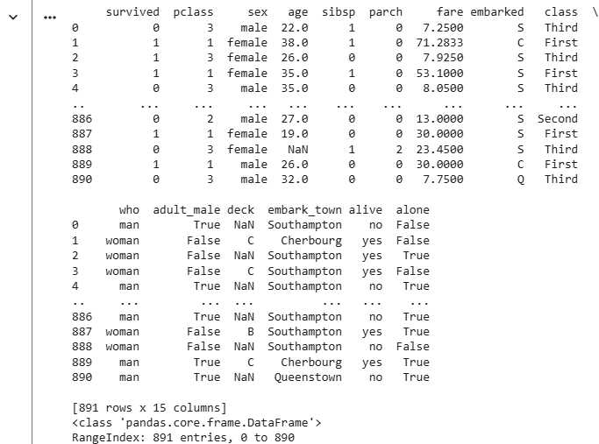
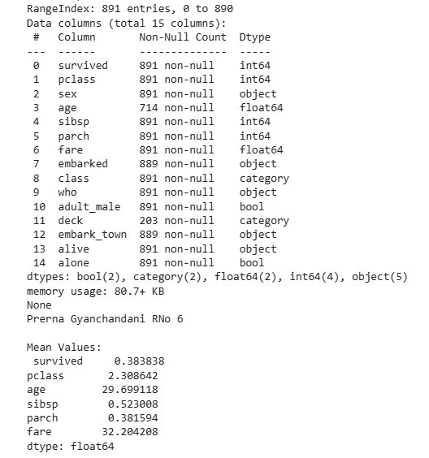
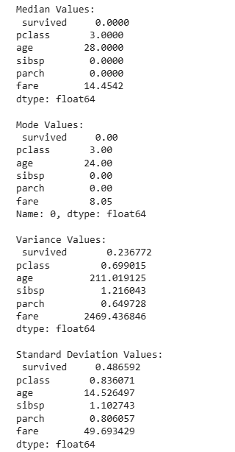
Method 2: Code:
#take age column
import pandas as pd
import numpy as np
from scipy import stats
df = sns.load_dataset('titanic')
num = df['age'].dropna()
# Manual Mean
mean = sum(num)/len(num)
# Manual Variance
variance = sum((x-mean)**2 for x in num)/len(num)
# Standard Deviation
std_dev = variance ** 0.5
# Coefficient of Variance
cv = std_dev/mean
print("Mean: ",mean)
print("Variance: ",variance)
print("Standard Deviation: ",std_dev)
print("CV: ",cv)
# Group - wise mean
print("\nGroup-wise Mean Age:\n",df.groupby('sex')['age'].mean())
Output:
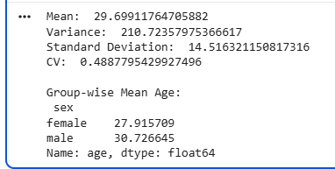

Practical No. 5
Aim: Analyze data distribution by plotting histograms and calculating skewness and kurtosis.
Name: Prerna Deepak Gyanchandani | Roll No.: KFPMSCCS06
Date: 5/3/26 | Sign:

Method 1 : Code:
import pandas as pd
import seaborn as sns
import matplotlib.pyplot as plt
# Load inbuilt dataset (penguins)
df = sns.load_dataset('penguins')
# Select numerical columns only
df_numeric = df.select_dtypes(include=['number']).dropna() # Drop NaN values for calculations
# Plot histograms
df_numeric.hist(bins=20, figsize=(10, 6), edgecolor='black', grid=False)
print("Prerna Gyanchandani RNo 6")
plt.suptitle('Histograms of Numerical Features in Penguins Dataset', fontsize=14)
plt.show()
# Compute Skewness - #measures asymmetry in data
skewness_values = df_numeric.skew()
print("\nSkewness Values:\n",skewness_values)
# Compute Kurtosis
kurtosis_values = df_numeric.kurtosis()
print("\nKurtosis Values:\n",kurtosis_values)
Output:
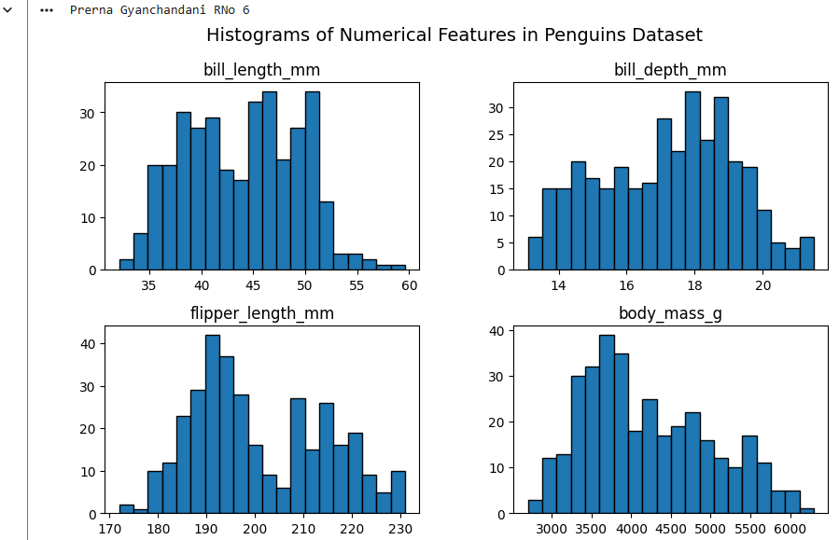
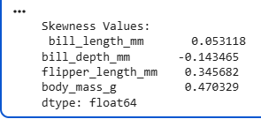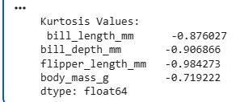
Method 2: Code:
import pandas as pd
import seaborn as sns
import matplotlib.pyplot as plt
from sklearn.datasets import load_diabetes #Loading dataset
from scipy.stats import skew,kurtosis,shapiro,boxcox
# Load inbuilt dataset (diabetes)
data = load_diabetes()
df = pd.DataFrame(data.data, columns=data.feature_names)
# Select numerical columns only
df_numeric = df.select_dtypes(include=['number']).dropna() # Drop NaN values for calculations
# Plot histograms
df_numeric.hist(bins=20, figsize=(10, 6), edgecolor='black', grid=False)
print("Prerna Gyanchandani RNo 6")
plt.suptitle('Histograms of Numerical Features in Penguins Dataset', fontsize=14)
plt.show()
sns.histplot(df_numeric, kde=True)
plt.show()
print("Skewness:",skew(df_numeric))
print("kurtosis:",kurtosis(df_numeric))
#stat,p = shapiro(df_numeric.sample(100))
#print("Shapiro p-value:",p)
# with penguins dataset
df = sns.load_dataset('penguins')
# Select numerical columns only
df_numeric = df.select_dtypes(include=['number']).dropna() # Drop NaN values for calculations
# Plot histograms
sns.histplot(df_numeric, kde=True)
plt.show()
print("Skewness:",skew(df_numeric))
print("kurtosis:",kurtosis(df_numeric))
# with penguins dataset
df = sns.load_dataset('penguins').dropna()
data = df['body_mass_g']
# Plot histogram + KDE
print("Prerna Gyanchandani RNo 6")
sns.histplot(data, kde=True)
plt.show()
# Skewness and Kurtosis
print("Skewness:",skew(data))
print("kurtosis:",kurtosis(data))
# Shapiro Test
stat,p = shapiro(data.sample(100))
print("Shapiro p-value:",p)
# Apply Box-Cox transformation
transformed_data, _ = boxcox(data)
print("Transformed Sample: ",transformed_data[:5])
Output:

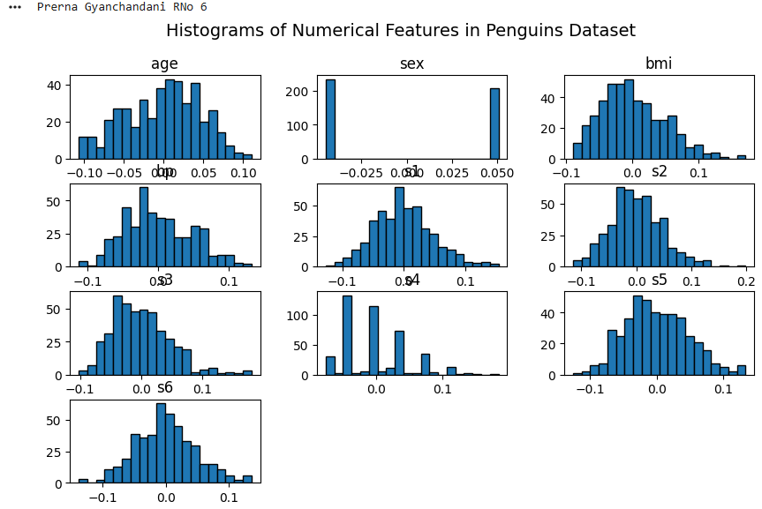
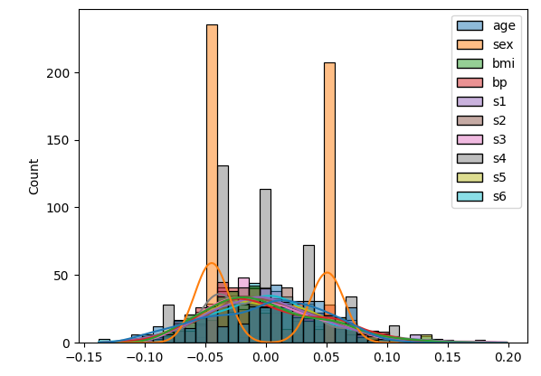
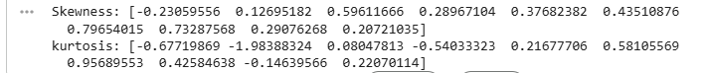
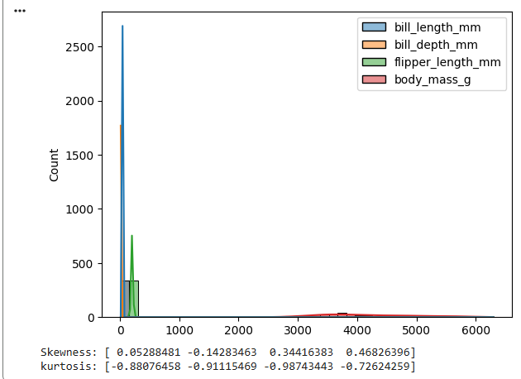
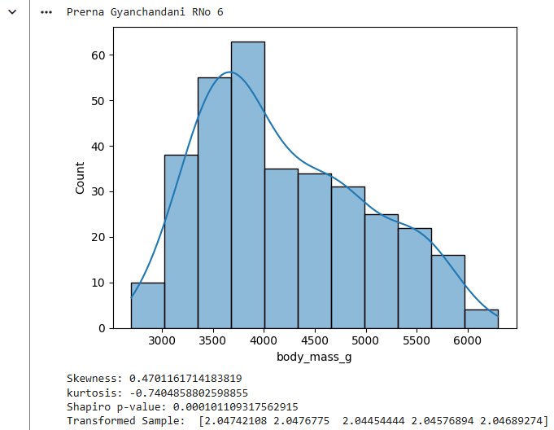

Practical No. 6
Aim: Create scatter plots, heatmaps, and boxplots to visualize relationships and outliers in the data.
Name: Prerna Deepak Gyanchandani | Roll No.: KFPMSCCS06
Date: 7/3/26 | Sign:

Method 1 : Code:
import pandas as pd
import seaborn as sns
import matplotlib.pyplot as plt
# Load inbuilt dataset (penguins) #Drop NaN values for visualization
df = sns.load_dataset('penguins').dropna()
# Scatter Plot: Relationship between Flipper Length and Body Mass
plt.figure(figsize=(8, 5))
# hue - color, style - shapes
sns.scatterplot(data=df, x='flipper_length_mm', y='body_mass_g', hue='species', style = "sex")
print("Prerna Gyanchandani RNo 6")
plt.title('Scatter Plot: Flipper Length vs. Body Mass')
plt.show()
# Heatmap: Correlation between numerical features
plt.figure(figsize=(6, 4))
sns.heatmap(df.corr(numeric_only=True), annot=True, cmap="coolwarm", linewidths= 0.5) #cmap-color of map
plt.title("Heatmap of Numerical Features in penguins Dataset")
plt.show()
# Boxplot: Detect outliers in Bill Length by Species
plt.figure(figsize=(8, 5))
sns.boxplot(data=df, x='species', y='bill_length_mm',hue="sex")
plt.title('Boxplot: Bill Length by Species')
plt.show()
Output:
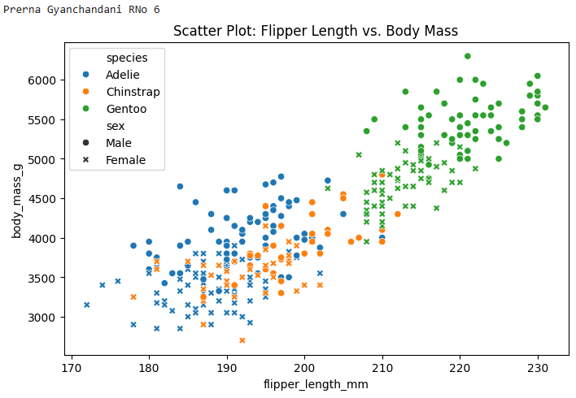

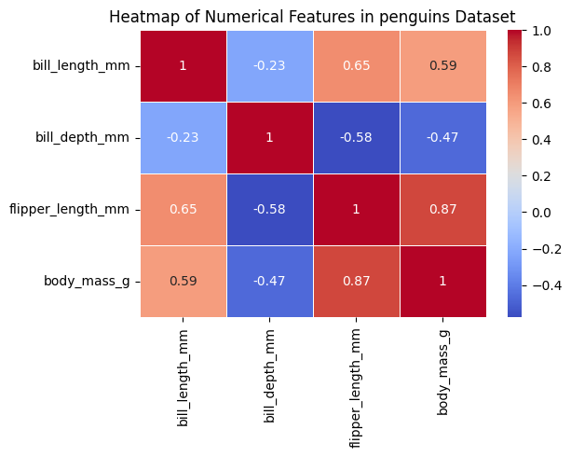
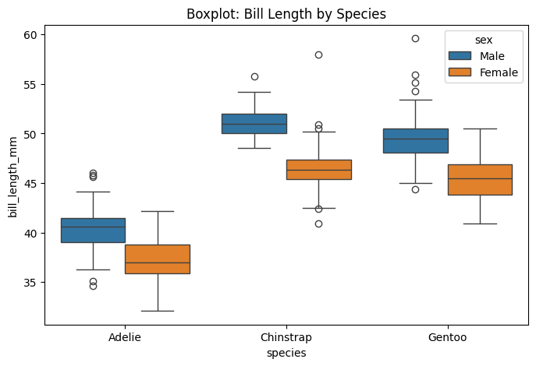
Method 2: Code:
import pandas as pd
import seaborn as sns
import matplotlib.pyplot as plt
# Load inbuilt dataset (penguins) #Drop NaN values for visualization
df = sns.load_dataset('penguins').dropna()
# Pairplot
sns.pairplot(df)
plt.show()
# Regression Line
sns.regplot(x='flipper_length_mm', y='body_mass_g', data=df)
plt.show()
# Heatmap
corr = df.corr(numeric_only=True)
sns.heatmap(corr, annot=True)
plt.show()
# Subplots
fig, ax = plt.subplots(1,3, figsize=(15,4))
sns.histplot(df['body_mass_g'],ax=ax[0])
sns.boxplot(x=df['body_mass_g'],ax=ax[1])
sns.scatterplot(x='flipper_length_mm',y='body_mass_g',data=df,ax=ax[2])
plt.show()
Output:
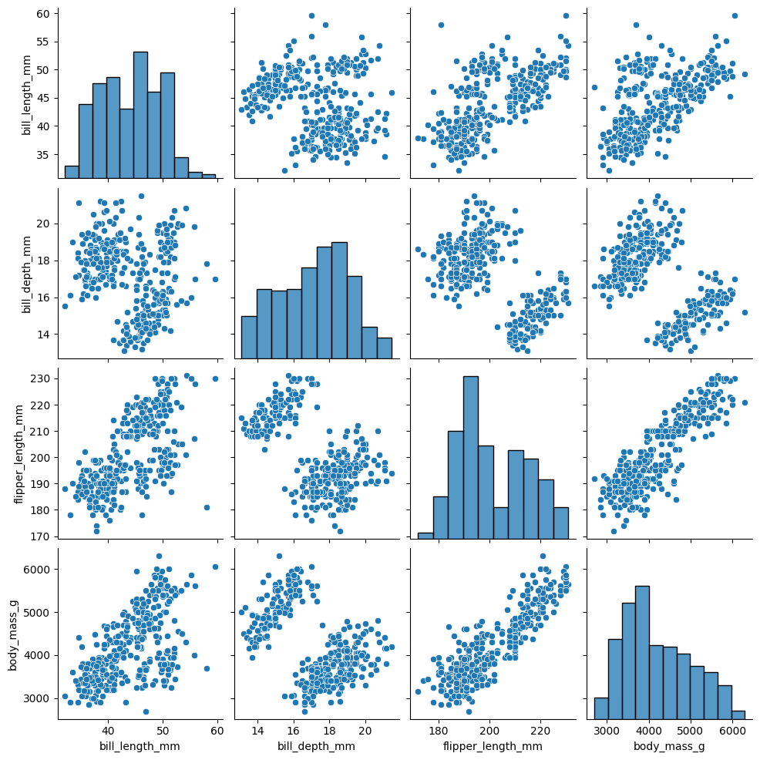
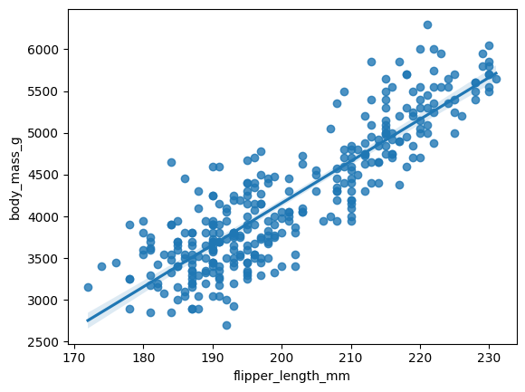
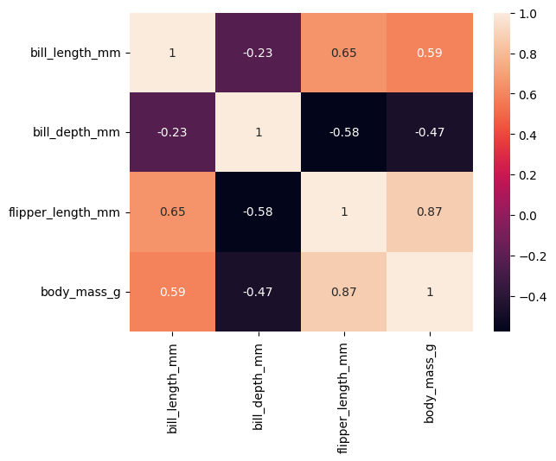
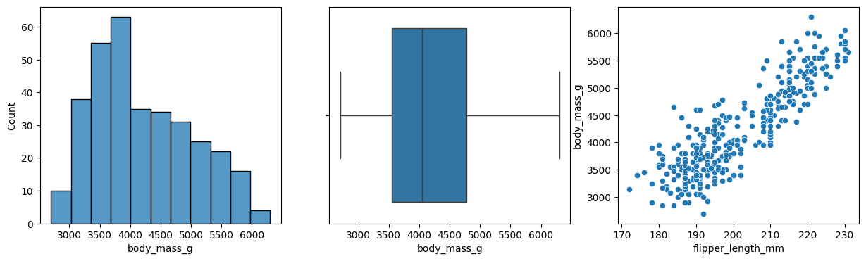

Practical No. 7
Aim: KNN and Decision Tree Classifier.
Name: Prerna Deepak Gyanchandani | Roll No.: KFPMSCCS06
Date: 16/3/26 | Sign:

Method 1 : Code:
from sklearn.datasets import load_wine
from sklearn.model_selection import train_test_split
from sklearn.preprocessing import StandardScaler
from sklearn.neighbors import KNeighborsClassifier
from sklearn.tree import DecisionTreeClassifier
from sklearn.metrics import classification_report
# Load dataset
data = load_wine()
X,y = data.data, data.target
# Train - test split
X_train, X_test, y_train, y_test = train_test_split(X,y, test_size=0.3, random_state=42)
# Scale data
scaler = StandardScaler()
X_train = scaler.fit_transform(X_train)
X_test = scaler.transform(X_test)
# k-NN
knn = KNeighborsClassifier(n_neighbors=5)
knn.fit(X_train, y_train)
print("Prerna Gyanchandani RNo.6")
print("k-NN Classification Report:")
print(classification_report(y_test,knn.predict(X_test)))
# Decision Tree
tree = DecisionTreeClassifier()
tree.fit(X_train, y_train)
print("Decision Tree Classification Report:")
print(classification_report(y_test,tree.predict(X_test)))
Output:
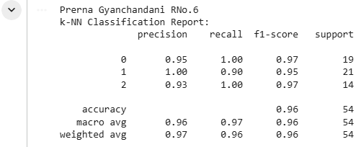
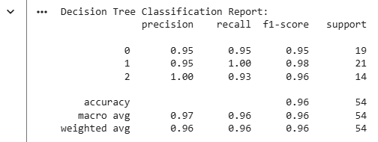
Method 2: Code:
from sklearn.datasets import load_wine
from sklearn.model_selection import train_test_split, GridSearchCV
from sklearn.preprocessing import StandardScaler
from sklearn.neighbors import KNeighborsClassifier
from sklearn.tree import DecisionTreeClassifier
from sklearn.metrics import confusion_matrix, classification_report
import seaborn as sns
import matplotlib.pyplot as plt
# Load Dataset
data = load_wine()
X,y = data.data, data.target
# Train - test split
X_train, X_test, y_train, y_test = train_test_split(X,y, test_size=0.3, random_state=42)
# Scale data
scaler = StandardScaler()
X_train = scaler.fit_transform(X_train)
X_test = scaler.transform(X_test)
# KNN
knn = KNeighborsClassifier(n_neighbors=5)
knn.fit(X_train, y_train)
print("Prerna Gyanchandani RNo.6")
y_pred = knn.predict(X_test)
print("Classification Report:")
print(classification_report(y_test,y_pred))
# Confusion Matrix
cm = confusion_matrix(y_test, y_pred)
sns.heatmap(cm, annot=True)
plt.title("Confusion Matrix")
plt.show()
# Decision Tree
tree = DecisionTreeClassifier(max_depth=3)
tree.fit(X_train, y_train)
print("Feature Importance: ",tree.feature_importances_)
Output:
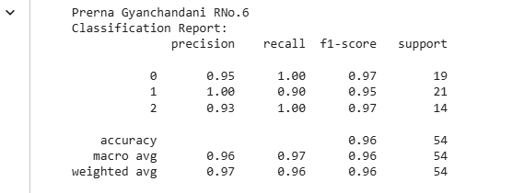
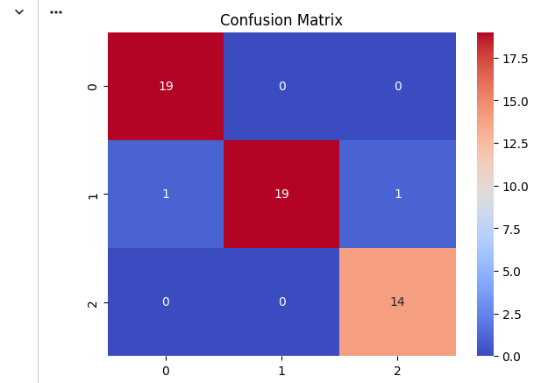

Practical No. 8
Aim: Simple and Multiple Linear Regression.
Name: Prerna Deepak Gyanchandani | Roll No.: KFPMSCCS06
Date: 16/3/26 | Sign:

Method 1 : Code:
import seaborn as sns
import statsmodels.api as sm
# Load dataset
tips = sns.load_dataset('tips')
# Simple Linear Regression (Tip ~ Total Bill)
X = tips[['total_bill']]
y = tips['tip']
X = sm.add_constant(X)
model_simple = sm.OLS(y, X).fit()
print(model_simple.summary())
# Multiple Linear Regression (Tip ~ Total Bill + Size)
X_multi = tips[['total_bill', 'size']]
X_multi = sm.add_constant(X_multi)
model_multi = sm.OLS(y, X_multi).fit()
print(model_multi.summary())
Output:
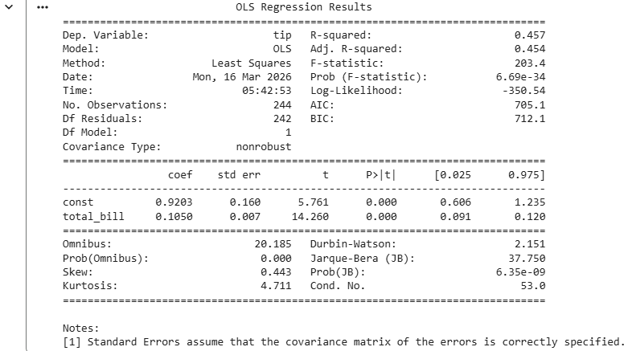
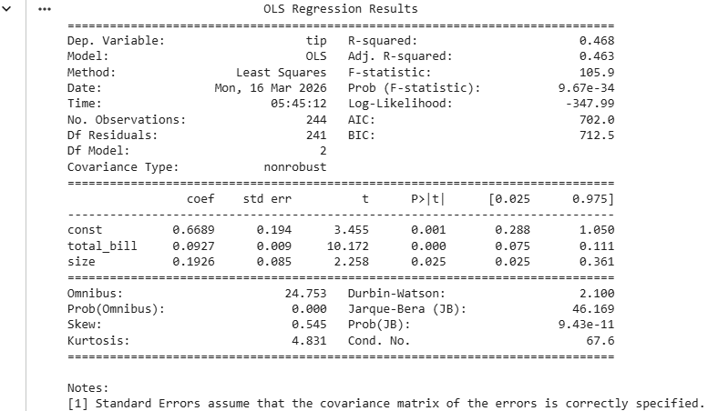
Method 2 - Code:
import seaborn as sns
from sklearn.model_selection import train_test_split
from sklearn.linear_model import LinearRegression, Ridge, Lasso
from sklearn.metrics import mean_squared_error, r2_score
import matplotlib.pyplot as plt
df = sns.load_dataset("tips")
X = df[['total_bill', 'size']]
y = df['tip']
# train model
X_train, X_test, y_train, y_test = train_test_split(X,y, test_size=0.3, random_state=42)
model = LinearRegression()
model.fit(X_train, y_train)
y_pred = model.predict(X_test)
mse = mean_squared_error(y_test, y_pred)
rmse = mse**0.5
r2 = r2_score(y_test, y_pred)
print("Prerna Gyanchandani RNo 6")
print("MSE: ",mse)
print("RMSE: ",rmse)
print("R2: ",r2)
# Residual plot
plt.scatter(y_pred, y_test - y_pred)
plt.show()
# Ridge & Lasso
ridge = Ridge().fit(X_train, y_train) # has same output as linear regression
lasso = Lasso().fit(X_train, y_train)
y_pred= lasso.predict(X_test)
mse = mean_squared_error(y_test, y_pred)
rmse = mse**0.5
r2 = r2_score(y_test, y_pred)
print("For Lasso Regression\nMSE: ",mse)
print("RMSE: ",rmse)
print("R2: ",r2)
# Residual plot
plt.scatter(y_pred, y_test - y_pred)
plt.show()
Output:
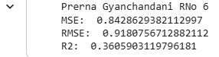
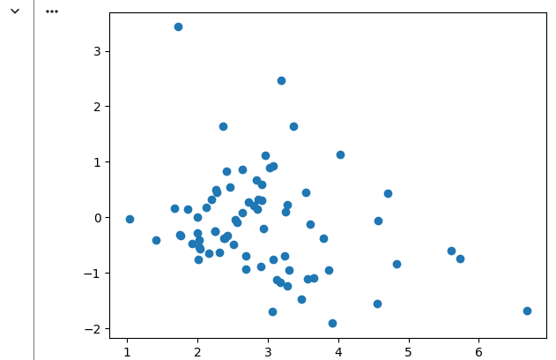
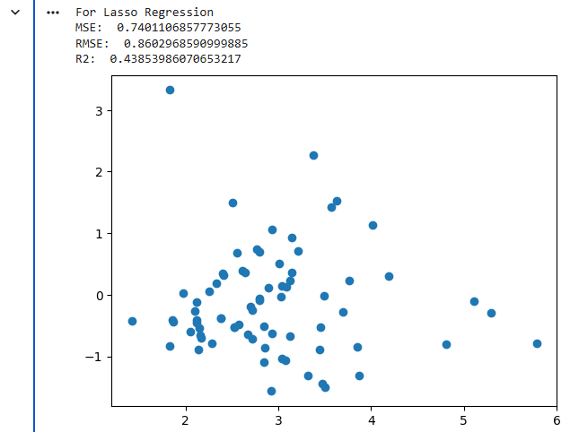

Practical No. 9
Aim: KNN and Decision Tree Classifier.
Name: Prerna Deepak Gyanchandani | Roll No.: KFPMSCCS06
Date: 24/3/26 | Sign:

Method 1 : Code:
from sklearn.datasets import load_wine
from sklearn.preprocessing import StandardScaler
from sklearn.decomposition import PCA
from sklearn.cluster import KMeans
from sklearn.cluster import DBSCAN
import matplotlib.pyplot as plt
data = load_wine()
X = StandardScaler().fit_transform(data.data)
pca = PCA(n_components=2)
X_pca = pca.fit_transform(X)
# K-means clustering
kmeans = KMeans(n_clusters=3, random_state=42)
labels_kmeans = kmeans.fit_predict(X)
# DBSCAN clustering
dbscan = DBSCAN(eps=1.5, min_samples=5)
labels_dbscan = dbscan.fit_predict(X)
# Plot K-means
plt.scatter(X_pca[:, 0], X_pca[:, 1], c=labels_kmeans, cmap='Set1')
print("Prerna Gyanchandani RNo 6")
plt.title('K-Means Clustering')
plt.show()
# Plot DBSCAN
plt.scatter(X_pca[:, 0], X_pca[:, 1], c=labels_dbscan, cmap='Set2')
plt.title('DBSCAN Clustering')
plt.show()
Output:
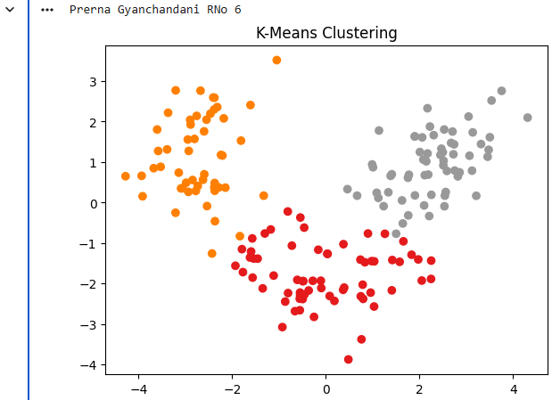
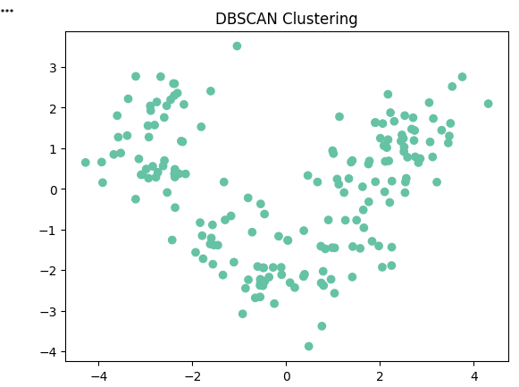
Method 2 : Code:

from sklearn.datasets import load_wine
from sklearn.preprocessing import StandardScaler
from sklearn.cluster import KMeans, DBSCAN
from sklearn.decomposition import PCA
from sklearn.metrics import silhouette_score
import matplotlib.pyplot as plt
data = load_wine()
X = StandardScaler().fit_transform(data.data)
# Elbow Method
inertia = []
for k in range(1,10):
km = KMeans(n_clusters=k, random_state=42)
km.fit(X)
inertia.append(km.inertia_)
plt.plot(range(1,10), inertia)
print("Prerna Gyanchandani RNo 6")
plt.title("Elbow Method")
plt.show()
# KMeans
kmeans = KMeans(n_clusters=3, random_state=42)
labels_kmeans = kmeans.fit_predict(X)
print("Silhouette Score:", silhouette_score(X, labels_kmeans))
# DBSCAN
db = DBSCAN(eps=1.5, min_samples=5)
labels_dbscan = db.fit_predict(X)
# PCA Visualization
pca = PCA(n_components=2)
X_pca = pca.fit_transform(X)
plt.scatter(X_pca[:, 0], X_pca[:, 1], c=labels_kmeans)
plt.title("K-Means Clustering")
plt.show()
Output:
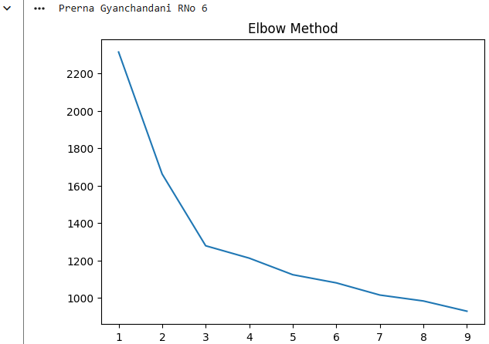
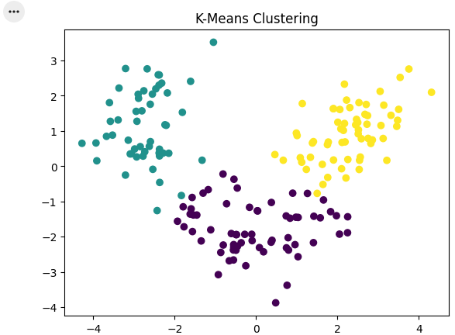

Practical No. 10
Aim: Apriori Algorithm for Market Basket Analysis.
Name: Prerna Deepak Gyanchandani | Roll No.: KFPMSCCS06
Date: 24/3/26 | Sign:

Method 1 : Code:
import pandas as pd
import seaborn as sns
from itertools import combinations
from collections import defaultdict
# Load inbuilt dataset
df = sns.load_dataset('titanic')
# Select categorical columns - We'll treat 'passenger class', 'sex', and 'embarked' as items "in a basket" (like items bought together)
df = df[['pclass', 'sex', 'embarked']].dropna()
# Convert each row into a transaction (basket) (basket of categorical attributes) transactions
transactions = df.astype(str).values.tolist()
# Step 1: Create frequent itemsets and count
def get_frequent_itemsets(transactions, min_support=0.1):
item_counts = defaultdict(int)
transaction_list = list(map(set, transactions))
total_tx = len(transaction_list)
freq_itemsets = []
# Generate all combinations (size 1 to 3)
for size in range(1, 4):
for transaction in transaction_list:
for itemset in combinations(transaction, size):
item_counts[itemset] += 1
# Filter by support (based on min support)
for itemset, count in item_counts.items():
support = count / total_tx
if support >= min_support:
freq_itemsets.append((itemset, support))
return freq_itemsets
# Step 2: Generate association rules
def generate_rules(freq_itemsets, min_confidence=0.6):
rules = []
itemset_dict = {frozenset(k): v for k, v in freq_itemsets}
for itemset in itemset_dict:
if len(itemset) >= 2:
for i in range(1, len(itemset)):
for antecedent in combinations(itemset, i):
antecedent = frozenset(antecedent)
consequent = itemset - antecedent
if consequent:
confidence = itemset_dict[itemset] / itemset_dict.get(antecedent, 1)
if confidence >= min_confidence:
rules.append((set(antecedent), set(consequent), confidence))
return rules
# Run Apriori
frequent_itemsets = get_frequent_itemsets(transactions, min_support=0.1)
rules = generate_rules(frequent_itemsets, min_confidence=0.6)
# Display results
print("Prerna Gyanchandani RNo 6")
print("Frequent Itemsets:")
for item, support in frequent_itemsets:
print(f"{set(item)}: support = {support:.2f}")
print("\nAssociation Rules:")
for antecedent, consequent, confidence in rules:
print(f"{antecedent} => {consequent} (confidence = {confidence:.2f})")
Output:
